

Codex

User Manual

April 2018

# Introduction

Thank you for taking an interest in the brand-new programming language and semantic learning platform Codex! Codex aims to provide a new way for programmers to share knowledge about various syntactical and semantical features of languages to help everyone improve their skills.

All of this is facilitated through a detailed post attribute system where users can vote on specific attributes of a post. Those attributes can then be used in searching and sorting. Codex differs from competitors by focusing and rewarding users for creating posts that teach the theory and understanding of concepts. This is done instead of the current method of simply posting solutions to posts. All of this should culminate in users of Codex gradually improving their overall skills and becoming more knowledge and therefore better programmers.

Thank you once again for using Codex!

* Thomas Hutchinson (Lead Developer)

Contents

1. Introduction 2

2. Signing In 4

2.1. Logging Out 5

3. Navigating the Site 6

4. Searching for Content 7

4.1. Search Results 8

5. Bounties 9

5.1. Creating a Bounty 10

6. Your Feed and Voting 11

6.1. Detailed Post View 12

7. Creating Posts 13

7.1. Deleting a Post 14

8. Saving Posts for Offline Viewing 15

9. So, what is the Point of Codex? 17

# Signing In

With Codex signing in is a simple process. All you need is a Google account and you are good to go! Codex uses Google’s secure login platform to ensure that your data is kept safe from any malicious users. It also ensures a quick login process and the ability to carry your data with you no matter which machine your login from whether that be mobile, laptop or computer

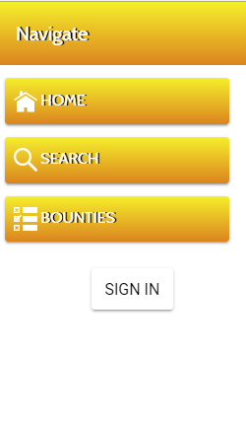

To sign in all you need to do is select the sign in button displayed in the left-hand side navigation bar. From there will be directed to Google’s secure login platform. This aspect of the login is completely handled by Google, so Codex does not have access to your password or login.

Upon logging in you will be returned to the homepage and after a moment of loading you will now be able to fully use Codex!

## Logging Out

When you are finished with Codex signing out is just as simple as signing in. Simply click the sign out button and your current session will be ended.

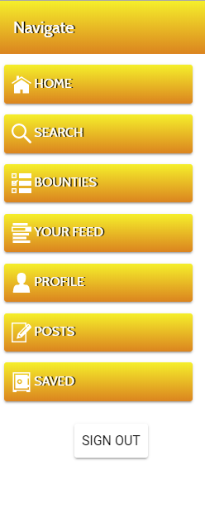

# Navigating the Site

Codex makes use of an always present left-hand side navigation bar. From here you can browse any page of Codex at your leisure. Simply click on a page and it will load. Also, don’t worry about losing data when navigating. If you don’t refresh or leave the page your form entries will remain even after changing page.

* Home – The home page is where you are taken to when you first connect to the site. It is also where you can find the news feed.
* Search – This is where you can search for all the posts contained on the site.
* Bounties – Bounties are a form of request you can make to the community. Here you can request other users create posts for you.
* You Feed – The feed contains a list of new posts created by the community. If you are just looking for something new, then this is the place to go.
* Profile – Here you can see any information about your self as well as view your created posts.
* Posts – Here you can create and post new content.
* Saved – Whenever you want to keep a post for later you can save it and then that post will appear in this tab.

There is also one final option that appears whenever you view the detailed page for a post. The view post tab will take you to the last viewed post.

# Searching for Content

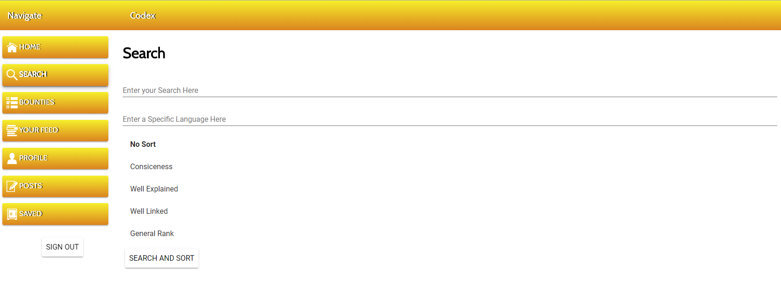Codex provides a powerful search engine that you can use to find any post on the site with ease! The search engine allows you to search for specific criteria and tags then sort that data on the attributes that are most important to you. All of this can be down in the matter of seconds giving you access to all that codex has to offer.

The search page can be broken down into three main elements. The tag search, the language search and the sort list. Starting with the tag search. You can search for a range of posts based on “tags”. Tags are the titles of posts or the author that created that post. So, for example if you wanted to search for a post by Barry. All you would need to do is type in Barry then hit the search button.

You then can further narrow down posts by entering a language too. This field can of course be left empty if you so wish. By entering a language into the language field, you will only see posts that specific to your programming/scripting language of choice.

Finally, you have the sort list. Here you have several options on how you want your data to be sorted. By selecting one of the five options all the returned data will be sorted dependent on that attribute. So, for example if you searched on conciseness the post with the highest conciseness rank would appear at the top.

Once you have entered all your criteria simply press the search and sort button and you will receive a list of responses.

## Search Results

After searching and finding some content you will be greeted with a list of results. These results will be sorted or not sorted depending on your choice. From here you have a few options about how to interact with your results.

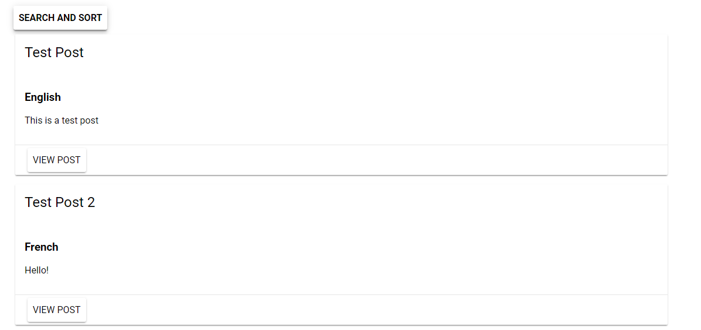

When finding content your results list will look a little like the image above. From here you can click the view post button for additional information about that post. From that page you can vote on the various attributes, view and post comments and save the post for offline storage.

# Bounties

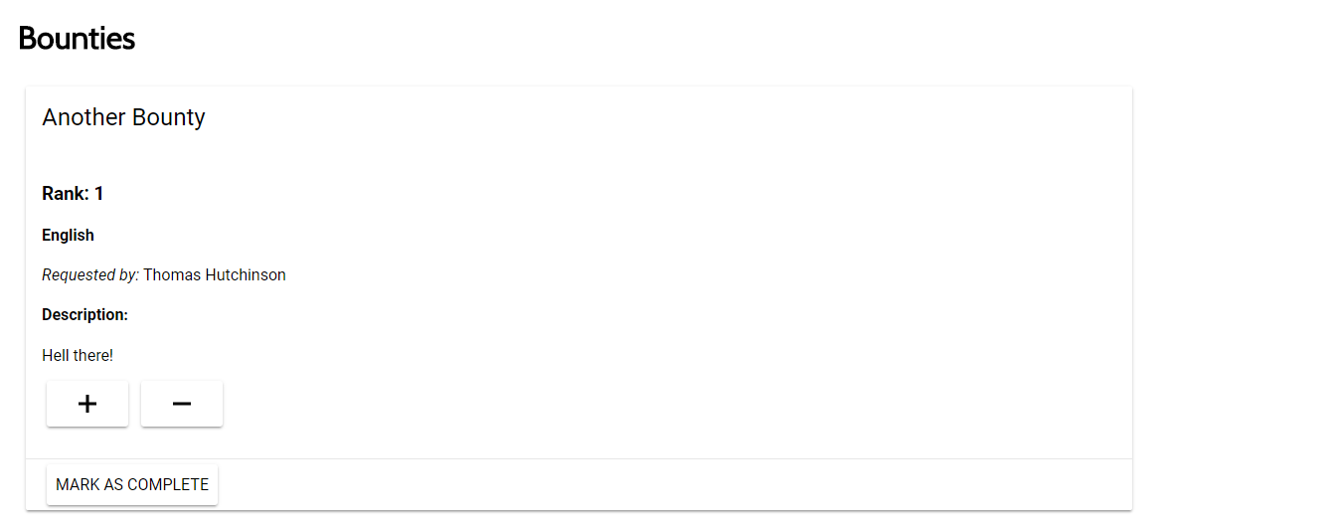

Bounties are very much like requests. If you have searched for an item of content but did not find it that might mean that nobody has created it. In that instance you can come along to the bounties page and create a bounty for others to view and vote on.

From the bounties page you can view other people’s bounties, create your own and vote on others. By voting on other bounties you increase their viewability. This is a way of ensuring that the most requested content gets seen first and increases its chances to finally being added to the site.

Once the content you have requested as been added to the site the bounty author can then mark that request as complete. That in turn will remove the bounty from the list allowing other bounties to rise to the surface.

## Creating a Bounty

Creating a bounty is just as simple as creating a post. All you need is a bounty title, a specific language and some content. From there you can press the submit button and wait for a kind user to come along and create the content you want.

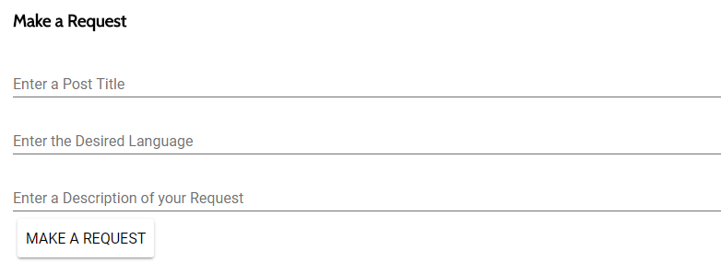

The Make A Request form can be found at the bottom of the bounties page. Here you can enter your request into the three fields and hit the submit button. Remember though to fill out all the fields otherwise your most will not be created. This is done to ensure vague bounties do not fill up the board. Remember, the more specific and detailed you are the more likely some is to come along and create the tutorial post you want.

# Your Feed and Voting

After the bounty board you have your feed. This is where you can find all the latest posts to Codex. You can also view the detailed post page like the search results. On top of that you can also vote on the various post statistics to help other in finding the content that matters to them.

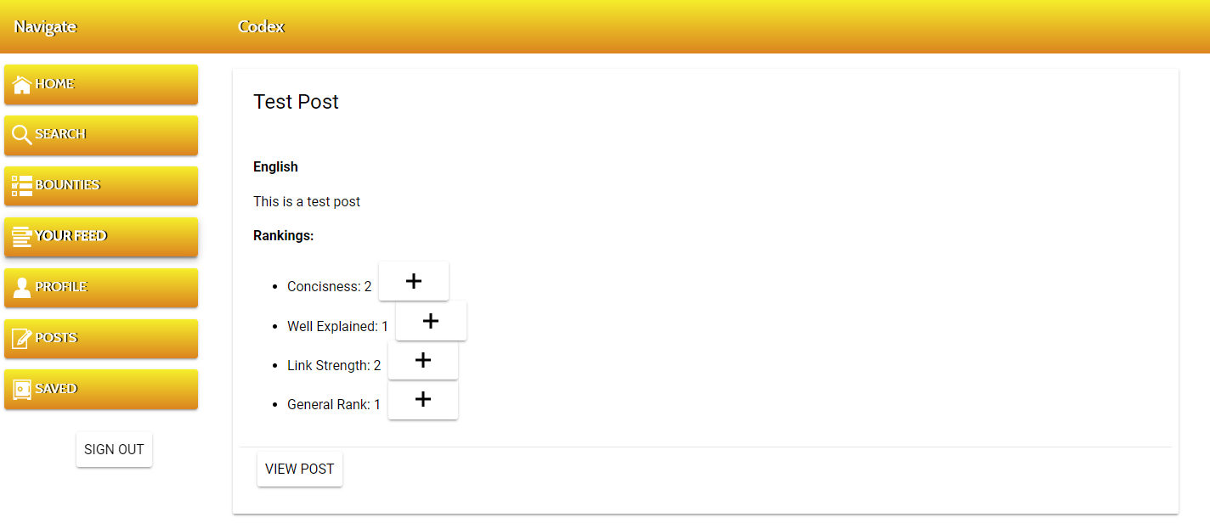

When connecting to the “Your Feed” page you will be greeted with a list of current posts. From here you can read and browse to your heart’s content. You can also press the view post button to be taken to the detailed post page where again you can view and post comments about that post. You can also vote on the various attributes of a post from this page.

By pressing the plus button next to an attribute, you will add a single point to that post’s attribute. You can do this once for every post with no limits on the amount of posts you may vote on. If you find you accidently voted on a post, you can then later remove that vote by pressing the vote button again next to the attribute of your choosing.

## Detailed Post View

By pressing the view post button, you will be taken to the detailed post page. Here you can view all the information about a post as well as vote on it’s various attributes and discuss that post with other users.

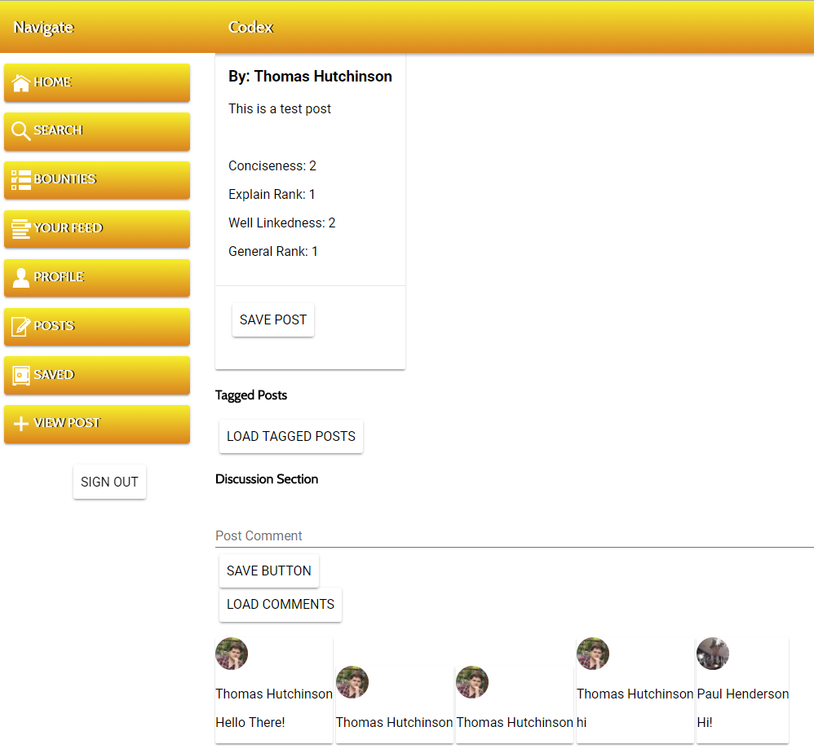

As well as voting and commenting you can also view any tagged posts. Tagged posts are other posts that the author has linked to their current tutorial. You can load any tagged posts by pressing the load tagged posts button. If after one press no posts have appeared, then unfortunately the author has not tagged any posts.

You can also comment on the post with other users. By entering some content in the post comment field then hitting the save button you can send comments of that will appear to other users viewing that post.

# Creating Posts

Creating posts is a simple process that only requires the filling out of several fields. In the matter of minutes, you can create a quick tutorial that demonstrates any element of semantical of syntactical relevance to any programming/scripting language you like.

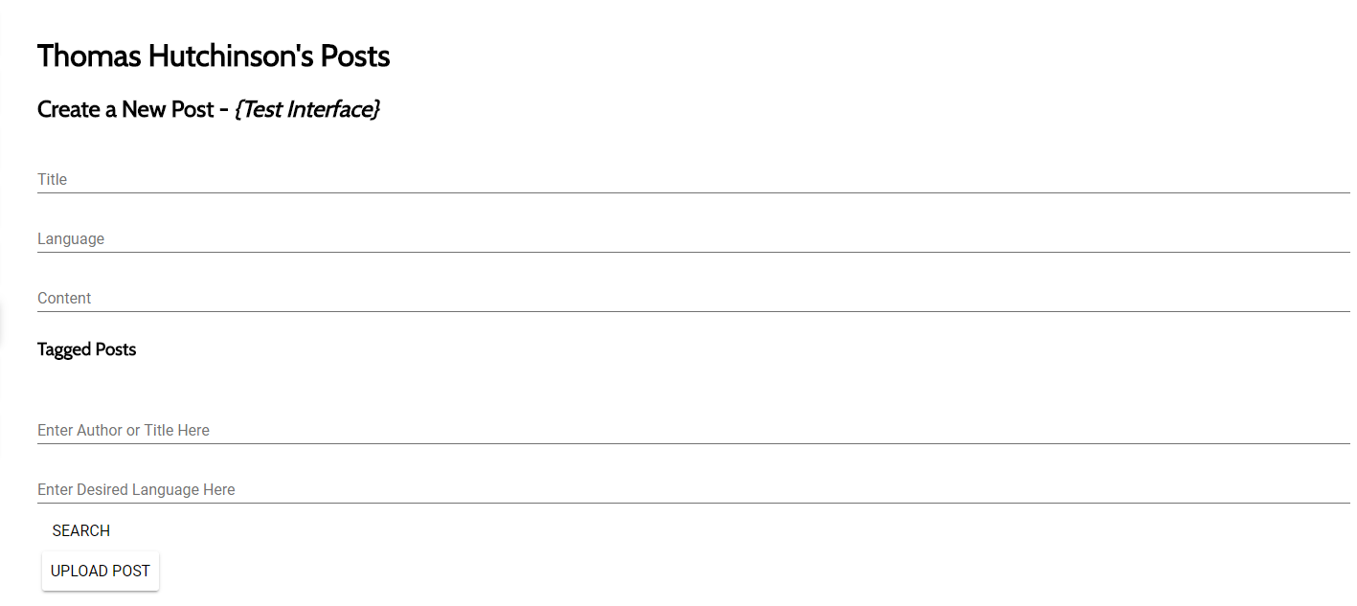

The title field will be title of your post. This will be the first thing a user searching or viewing your post will see so make sure it properly describes the following content.

Language defines what programming/scripting language your post applies to. If it applies to multiple feel free to add them all in.

You then have the content field. Here you can add the body of your post describing the syntactical or semantical feature of your choosing.

Finally, you have the tagged posts feature. Tagging a post is a simple process:

* First you search for a post much like you would on the search page.
* Once you have found the post in the search list that you want to tag press the tag post button.
* That in turn, will add that post to the tagged post list. You now know that when you create that post the tagged post will appear alongside your post on the detailed post page.

After you have entered your content and tagged any posts you want you can press the upload post button. This will send your post off to the Codex server’s where other users will be able to view and interact with your post.

## Deleting a Post

If after creating a post, you decide it was not quite ready for publish you can choose to delete that post. Deleting a post will completely remove it from the database so you have no way of getting it back.

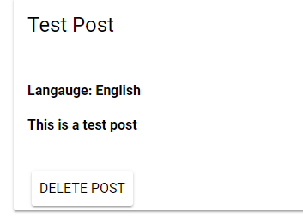

To delete a post simply press the post delete button. This will permanently remove the post from the website so be sure you want to delete the post before pressing it. You will know the post has been deleted when it is completely removed from your created post list.

# Saving Posts for Offline Viewing

Sometimes you may not have connection to the internet or you are just on a mobile connection and you want to save every byte of data. Well don’t worry as Codex can help you out there.

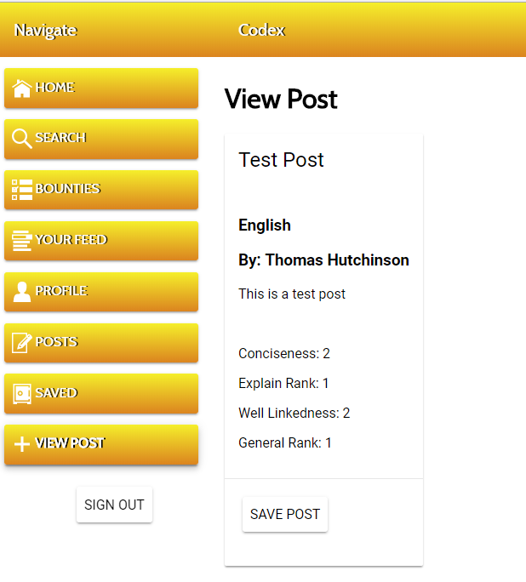

By navigating to the detailed post view page, you can find the save post button. When you press this button, it will be added to your local storage. You will now be able to view that post offline from the saved posts page. You can save as many posts as you like so feel free to save away!

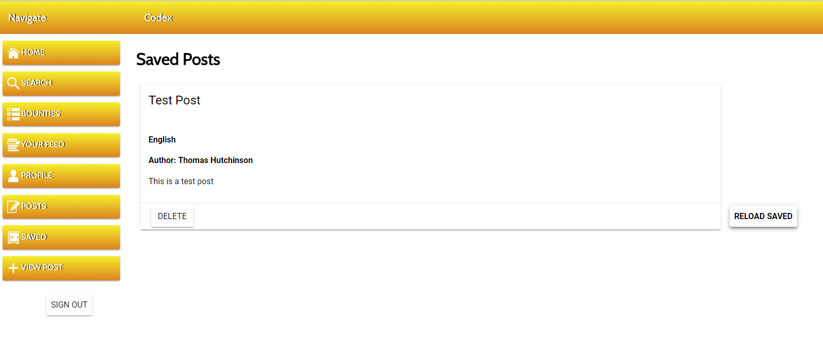

When you arrive at the saved posts page you may find no posts are present even though you have already saved posts. Well do no worry as by pressing the marked reload saved button any posts stored in your local cache will be loaded. So, remember if your posts aren’t there press the reload saved button.

You can also remove a post from local storage when you are finished with it by pressing the delete button. This will delete the post from your local storage if you decide you no longer need it. This feature is also great for keeping a track of a commonly used post. If you find yourself constantly referring to the same post, then it might be worth adding it to your saved list for easy future access.

Also remember though that this feature makes use of your browser’s local storage. That means if you clean your storage/cache then any saved posts will also be gone. So be careful with what you clear.

# So, what is the Point of Codex?

Codex aims to be a new step for learning programming languages. At the core of Codex is the idea that programmers who understand the background of their craft can perform better and make higher quality products.

Other sites simply give you the solution and while when you’re working towards a deadline that can be very useful programmers need to be constantly working on their skills and improving. Codex aims to facilitate that improvement through relying on crowed sourced posts. Programmers, students and teachers can work together to help everyone increase their knowledge and not just ignore the facts and details.

While it may not be the easiest route, Codex aims to give programmer the opportunity to improve themselves in the long run. If you want to help the development of Codex, please take a moment to fill out the following survey about your times with the application. https://goo.gl/forms/NwGRoONHs0AD5TQK2